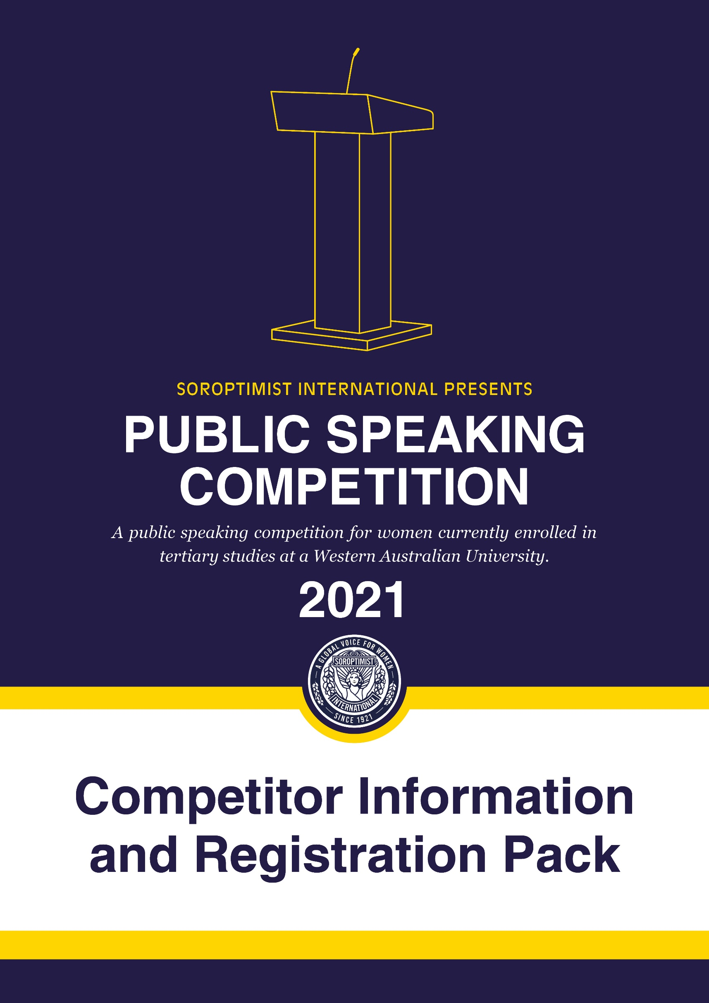

It is with great pleasure that we welcome you to the 2021 Soroptimist International Western Australia Public Speaking Competition.

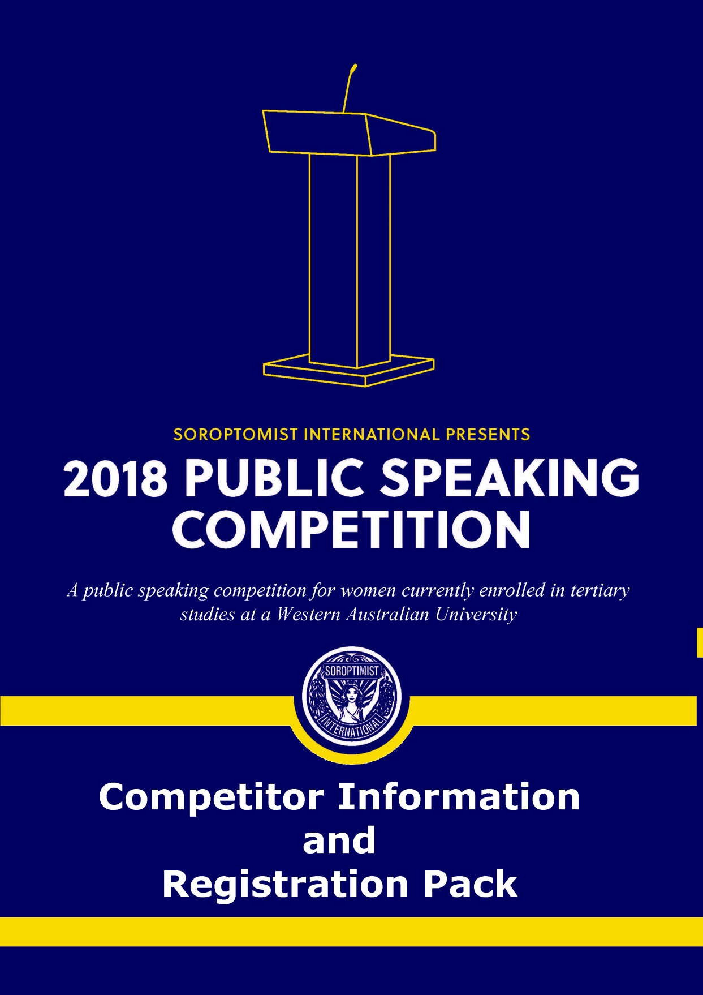

WELCOME

## What is Soroptimist International?

Founded in 1921, Soroptimist International is a global volunteer movement with a network of over 72,000 club members in 121 countries. Advocating for human rights and gender equality, at the heart of Soroptimist International’s advocacy is its work across six United Nations (UN) Centres, where our UN representatives ensure that the voices of women and girls are heard. Our membership work on grassroots projects that help women and girls achieve their individual and collective potential, realise aspirations and have an equal voice in communities worldwide. Each Soroptimist club belongs to one of the five Soroptimist International Federations: Great Britain & Ireland, Europe, The Americas, Africa and South West Pacific.

For more information see: <https://www.soroptimistinternational.org/>

## Soroptimist Clubs in Western Australia

The Soroptimist clubs in Western Australia all belong to the Soroptimist International Federation of the South West Pacific.

Much of the important Soroptimist work occurs at an individual club level. In Western Australia there are approximately 300 members in 15 clubs stretching from Karratha to Albany. Each year club members organise fundraising and service projects within their local communities.

The clubs collectively work together to organise state-wide projects such as the Public Speaking Competition and the Stella Giles Award for Achievement, which is a biennial award that recognises a Western Australian woman who has made a significant contribution to her chosen field and provides financial support towards the costs of running a project that will benefit women and girls.

For more information on this award see: http://www.soroptimist-wa.org.au/stella-giles-award/

## Why is Soroptimist International organising this competition?

Public speaking is a core skill for the twenty-first century. It’s the most impactful way to share who you are and what you care about. It is an opportunity to inform, educate and persuade those around you. Effective public speaking requires confidence, engagement and articulation. These are all vital leadership skills.

We would like to provide women with an opportunity to develop their public speaking skills and speak about the issues that they are passionate about. A panel of judges will be carefully selected and will be able to provide competitors with feedback after the competition.

Soroptimists aim to improve the lives of women and girls through awareness, advocacy and action. This competition embodies both the awareness and advocacy aspects. It will be an opportunity for university students to learn about Soroptimism and the projects that are happening in each club.

**Topics**



SOROPTIMIST PUBLIC SPEAKING COMPETITION

Competitors may choose to speak on any of the following topics:

* “No country can ever truly flourish if it stifles the potential of its women and deprives itself of the contribution of half of its citizens.” (Michelle Obama)
* #ChoosetoChallenge – A challenged world is an alert world and from challenge comes change. (2021 IWD Theme)
* We do not inherit the earth from our ancestors, we borrow it from our children.
* What are the essential elements for women’s empowerment?

**Duration of speech**

Each participant should speak for at least four minutes and no more than six minutes. Marks will be deducted for speeches outside of this range.

**Purpose of the speech**

The speech content will be marked on whether it was **informative, convincing** or **persuasive.**

These criteria align with Soroptimist International's objective of increasing advocacy at a global level.

**Dates and Locations**

There will be two rounds. The preliminary round will be held at a venue within your University. For the relevant information for each university please see page 6.

**Round 2 – Final**

The final will be from **2pm** on **Saturday   
8 May 2021** at the University of Notre Dame in Fremantle. The final will include light refreshments before and after the competition.

**Prizes**

There are prizes for the winner of each Round.

**Round 1**

The Soroptimist clubs hosting Round 1 have sponsored a cash prize of $250 for the Round 1 winner.

**Round 2**

The Soroptimist Region of Western Australia has sponsored a cash prize of $500 for the winner of the final.

In addition to this, the final will provide a fantastic networking opportunity for the competitors as well as the experience of speaking in front of a panel of distinguished guests.

**And after …**

Following the final, all participants will have the opportunity to attend a networking seminar to hear and interact with like-minded women in leadership roles. This will be held on 27 May 2021 at Southcare, 53 Bickley Crescent, Manning WA 6152.

# Competition Rules



SOROPTIMIST PUBLIC SPEAKING COMPETITION

## Registration

The closing date for registrations is one week before the competition closes at your University. Please see page 6 for details. Late registrations will not be accepted.

Registration is completed by completing the registration form on pages 4 and 5 and emailing it to Vida Corbett at (siwesternaustralia@siswp.org).

Alternatively, competitors can complete the online registration form, which can be found at <https://form.typeform.com/to/bFOXUjEe>.

## Eligibility

The competition is open to all women who are currently enrolled at a university in Western Australia.

**Marking Guide**

To standardise the judging across universities, the judging criteria in each competition will be the same. The marking rubric is attached on page 7.

## Questions

If you have any questions, please feel free to email Vida at: siwesternaustralia@siswp.org.

## Competition Guidelines

The use of props or visual aids is not permitted. Microphones and audiovisual equipment may be used by Soroptimist International for the purpose of amplifying and recording the speech. Palm cards and other referral material for participants will be permitted.

Competitors who plagiarise content may face disqualification – quotes and statistical evidence is permitted.

Competitors who, in the opinion of the Club, act in a manner which would bring themselves or Soroptimist International into dispute may face disqualification.

For Round 1, Clubs have the discretion to choose registrations to compete if the volume of registrations exceeds the capacity of competitors that can be accommodated.

Clubs reserve the right to video or audio record the competitors’ speeches and distribute the speech to club members. Additionally, photos may be taken and used for publicity.

If competitors do not wish for their speech to be recorded or photos to be taken, please disclose this when submitting the application form. This will not affect the Club’s decision when exercising discretion if there are too many registrations.

**About the competitor**



REGISTRATION FORM (Page 1 of 2)

Name: Click here to enter text. Date of birth: Click here to enter text.

Address: Click here to enter text. Contact number: Click here to enter text.

Email address: Click here to enter text.

Name of University: Click here to enter text.

Course enrolled in: Click here to enter text.

Why did you choose this course of study?

|  |
| --- |
| Click here to enter text. |

**About the speech**

Topic: Click here to enter text.

Title of Speech: Click here to enter text.

Tell us why you have decided to speak on this issue.

|  |
| --- |
| Click here to enter text. |

What has interested you about Soroptimist International? (You may want to look at the following websites to learn more about the organisation: <http://www.soroptimist-wa.org.au/> and <https://www.soroptimistinternational.org/>.)



REGISTRATION FORM (Page 2 of 2)

|  |
| --- |
| Click here to enter text. |

I grant permission for Soroptimist International to take photos/recordings of me during the competition and that such photos/recordings may be used for the purpose of publicity, advertising, illustration or website/Facebook content. Yes  No

Signature ____________________________________________________________ Date ______________________

|  |  |  |  |  |
| --- | --- | --- | --- | --- |
| **University** | **Soroptimist International  Host Club** | **Date and Time of Round 1** | **Round 1 Venue** | **Closing Date for Registrations** |
| Notre Dame | SI Fremantle | Wednesday, 21 April 2021  5.30 pm | Santa Maria Lecture  Theatre (ND1/102) | Wednesday 14 April  by 5.00 pm |
| Edith Cowan University – Joondalup | SI Joondalup /  SI Maylands Peninsula | Thursday, 22 April 2021  6.00 pm | Moot Court, ECU Joondalup Library | Thursday 15 April  by 5.00 pm |
| University of Western Australia | SI On the Terrace | Tuesday, 20 April 2021  5.30 pm | Arts Lecture Room 5  G61 | Tuesday 13 April  by 5.00 pm |
| Curtin University | SI South Perth / SI Perth | Wednesday, 21 April 2021  6.00 pm | Curtin Medical School 410.428 | Wednesday 14 April  by 5.00 pm |
| Murdoch University | SI Rockingham | Thursday, 15 April 2021 1.30 pm | Social Sciences Building  440.2.038 | Thursday 8 April  by 5.00 pm |
| **Grand final to be held on Saturday 8 May, 2.00 pm at Notre Dame University.** | | | | |



SOROPTIMIST PUBLIC SPEAKING COMPETITION



SOROPTIMIST PUBLIC SPEAKING COMPETITION

|  |  |  |  |  |
| --- | --- | --- | --- | --- |
| MATERIAL CRITERIA | **30 points** | **20 points** | **10 points** |  |
| **Material** | Material organised around a clear purpose and based on one theme. Information was accurate, relevant and up to date. | Theme is evident, material could be more clearly organised and the topic could have been more specific, information was accurate but out of date. | Purpose and basic theme of speech unclear, topic was too broad, information was incorrect or not relevant to topic. | /30 |
| **Inform, Convince, Persuade** | Completely | Partially | Not at all | /30 |
|  |  |  |  |  |
| SKILLS CRITERIA | **15 points** | **10 points** | **5 points** |  |
| **Voice and diction** | Speaker’s use of language was excellent; the words were put together well to convey meaning without appearing to be memorised.  Correct grammar. | Speaker did not read entire speech but hesitated and stumbled to some degree. Grammar was inconsistently correct. | Speaker read speech, stumbled with frequent hesitations, words were not put together well, meaning difficult to understand, poor grammar. | /15 |
| **Body Language** | Used natural movement, descriptive gestures that displayed energy, created mood, and helped the audience to visualise. Occasionally glanced at notes, made consistent and meaningful eye contact with audience. | Used some movement and gestures, which did not enhance the speech, some eye contact but relied on notes to a level of distraction. | Used movement and gestures that distracted from the speech, were not coordinated with speech, little to no eye contact, frequently looking at the floor or their notes. | /15 |
|  |  |  | **Total** | /90 |

Judging Criteria



SOROPTIMIST PUBLIC SPEAKING COMPETITION

Judges' Comments

**___________________________________________________________________________________________________________________________________________________________**

**___________________________________________________________________________________________________________________________________________________________**

**___________________________________________________________________________________________________________________________________________________________**

**___________________________________________________________________________________________________________________________________________________________**

**___________________________________________________________________________________________________________________________________________________________**

**___________________________________________________________________________________________________________________________________________________________**

**___________________________________________________________________________________________________________________________________________________________**

**___________________________________________________________________________________________________________________________________________________________**

**___________________________________________________________________________________________________________________________________________________________**

**___________________________________________________________________________________________________________________________________________________________**

**___________________________________________________________________________________________________________________________________________________________**

**___________________________________________________________________________________________________________________________________________________________**

**___________________________________________________________________________________________________________________________________________________________**

**___________________________________________________________________________________________________________________________________________________________**

**___________________________________________________________________________________________________________________________________________________________**

**___________________________________________________________________________________________________________________________________________________________**