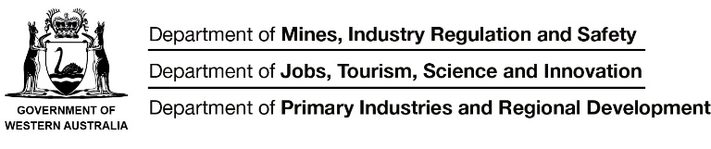

**Applications for the 2019 Interagency Graduate Program with** the Department of Mines, Industry Regulation and Safety, Department of Jobs, Tourism, Science and Innovation and Department of Primary Industries and Regional Development **have now opened.**

**We are currently looking for 15 graduates with a range of bachelor degrees:**

**Department of Jobs, Tourism, Science and Innovation**

Bachelor degree in one of the following fields (2 positions total available):

* Arts (Anthropology; History; Politics; International Relations)
* Commerce
* Communication
* Economics
* Law
* Science
* Engineering and Mining
* Environmental Science
* Finance
* Urban and Regional Planning

**Department of Mines, Industry Regulation and Safety**

Bachelor degrees across various fields will be considered (13 positions total available):

* Information Technology
* Economics and Finance
* Accounting
* Human Resources and Employment Relations
* Information Management and Records Management
* Communications and Marketing
* Law
* Public policy  and Legislation
* Data Analytics
* Security, Criminology and Investigations
* Building Surveying

Please note the Department of Primary Industries and Regional Development will not be recruiting for the 2018 graduate intake.

**To be eligible for the Graduate Program you must:**

* Be an Australian citizen or permanent resident.
* Be completing your first degree qualification in the current year (i.e. 2018) or have completed it in the preceding calendar year (i.e. 2017).

**Each Department is running its own recruitment and selection process*.***

For more information on the specific roles available and to apply for the positions, please visit these websites:

**Department of Mines, Industry Regulation and Safety**

* Available graduate positions:  [Apply now](http://www.dmp.wa.gov.au/About-Us-Careers/Graduate-program-1438.aspx)
* The Graduate Program: [www.dmirs.wa.gov.au/graduateprogram](http://www.dmp.wa.gov.au/About-Us-Careers/Graduate-program-1438.aspx)
* More information about the Department: [www.dmirs.wa.gov.au](http://www.dmirs.wa.gov.au/)

**Department of Jobs, Tourism, Science and Innovation**

* Available graduate positions visit: [www.jobs.wa.gov.au](http://www.jobs.wa.gov.au/) (search for Agency ‘Department of Jobs, Tourism, Science and Innovation’ and Occupation ‘Graduate’)
* The Graduate Program: [www.jtsi.wa.gov.au/graduateprogram](http://www.jtsi.wa.gov.au/graduateprogram)
* More information about the Department: [www.jtsi.wa.gov.au](http://www.jtsi.wa.gov.au)

Applications must be submitted via: [www.jobs.wa.gov.au](http://www.jobs.wa.gov.au/)

You can also contact Alyce Rengel, Graduate Program Coordinator on (08) 9222 3866 or [graduates@dmirs.wa.gov.au](mailto:graduates@dmirs.wa.gov.au)

**Applications close 5pm (WST) Monday 3 September 2018**

