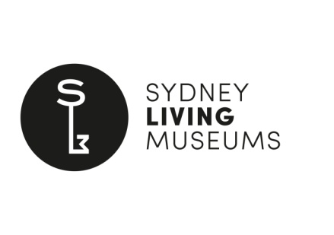
Student Information Form
Thank you for your interest in undertaking an internship with Sydney Living Museums (SLM).
Please be aware that students wishing to apply for any SLM internship must meet ALL of the following criteria:
- Students must be currently enrolled in a recognised Australian tertiary educational institution
- The internship must be a mandatory component of the student’s tertiary degree or course OR directly related to the subject of the degree or course
- The student’s educational institution must provide insurance cover
Please complete the form below and submit it, along with a letter of interest and a copy of
your CV, to Alison Waterhouse internships@sydneylivingmuseums.com.au by the advertised deadline. Once we have reviewed all applications we will notify you as to whether you will be invited for interview.
Student Name
Educational Institution
Degree/Course
Subject area
Phone
Email
Name of internship are you applying for:
Are you able to commit to the timeframe shown on the project outline for this internship? |  |  |  | YES/ NO
Please provide detail on your availability (days of the week):
Please provide the name and contact details of an academic referee
Academic Referee Name
Position
Contact phone
Email
Sydney Living Museums requires you to ensure that your educational institution provides:
- Endorsement for you to undertake this internship
- Documentation confirming that your educational institution will provide insurance for you to undertake an internship with SLM
Please be aware that failure to provide this information will prevent you from applying for an internship with SLM.
Please provide the name and contact details of the staff member at your educational institution who can provide this information.
Staff Name
Position
Contact phone
Email
Current Sydney Living Museums employees are not eligible to apply for SLM internships. I confirm I am not a current SLM employee |  |  |  |  | YES/ NO

