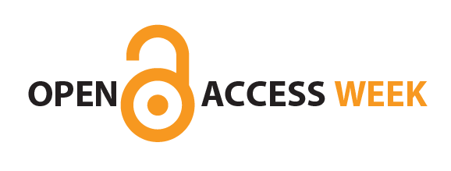
The University

of Notre Dame
Australia

Open Access Week –
Wikipedia Editing Workshop

Presented by Gideon Digby, Vice-President of Wikimedia Australia
Workshop by Lydia Dawe, Liaison Librarian, UNDA

Wednesday 25th October

1.30pm-3.30pm

Wikipedia is the one of the first open access resources on the internet that many people consult for information on a topic. Because of this, our research community has an important interest in ensuring that Wikipedia has accurate, comprehensive coverage of content that links to freely available open access research literature.
The session will cover:
- Detailed guidance for creating and editing Wikipedia entries in your area of research
- Suggestions for improving relevant articles
- Learning how to edit Wikipedia for beginners
- Using Open Access repositories and directories to discover articles to add to Wikipedia
- Wikipedia in the academic context
- Best practices for communication with other Wikipedia editors

Registrations will close 1 day before the event. Please register your place here

Venue: Tannock Hall of Education ND4/203
Cnr Cliff and Croke Streets, Fremantle
The University of Notre Dame Australia

For further information 9433 0735 | jackie.stevens@nd.edu.au

