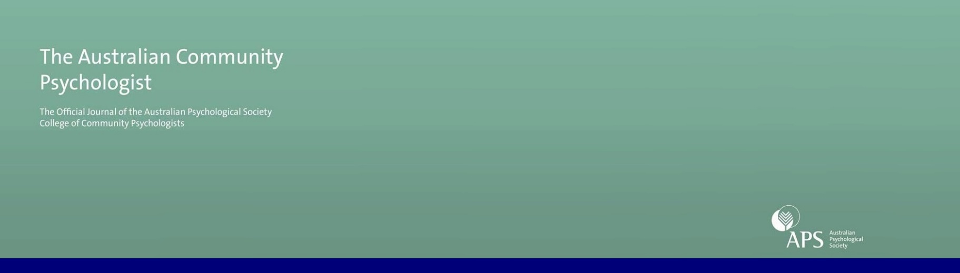
Latest Issue of the Australian Community Psychologist
Special Issue on the 13th Trans-Tasman Community Psychology Conference: Critical Conversations
The 13th Trans-Tasman Community Psychology College Conference in Melbourne was one of the biggest ever, with more than 80 delegates attending across 3 days in April 2017. Now the latest edition of the Australian Community Psychologist features a selection of peer-reviewed papers from the conference, including Chris Sonn’s welcoming keynote address.
The specific focus of the conference was to revisit the critical foundations of community psychology to promote critical reflexivity and identify opportunities for change. The nine papers featured in the special issue continue this theme, covering a diverse array of topics with authors from Australia, Bhutan, South Africa, and Aotearoa New Zealand. Topics include vicarious trauma in sensitive research and community projects, promoting the social and emotional wellbeing of Aboriginal children, applying community psychology principles to the study of suicidality, the status of diverse sexualities and genders in community psychology research and practice, and the transformative potential of nature strip gardens. Conference delegates were also treated to an exhibition of images from Motherhood Unmasked, a community arts project which is one of four highlighted in a paper critically reflecting on the role of mothers in society and how mothering is valued more generally. So, something for everyone in our first issue for 2018.
Please visit our website to access the issue.
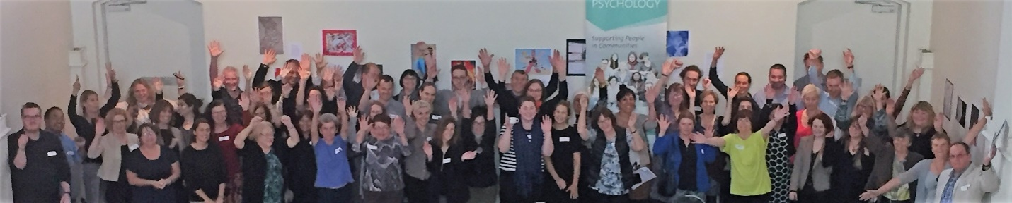

Special Issue call for Papers
The Australian Community Psychologist, Vol. 30, Issue 2
The second issue of 2019 will be a special issue devoted to addressing the question:
Critical community psychology and qualitative research methods: are they compatible?
Guest Editors: David Fryer (University of Queensland, Australia and University of South Africa) and Paul Duckett (Central Queensland University, Australia)
This Special Issue will explore issues raised when modernist qualitative research methods are deployed to support radically critical community psychological knowledge claims and whether, and if so how, issues of meta-theoretical consistency have to be addressed by those engaged in knowledge work underpinned by assumptions of both modernist qualitative research and of radically critical community psychology.
By ‘radically critical community psychology’ we mean community psychology which engages in critique in the sense of the Foucauldian tradition of uncovering and resisting the effects of community psychological ‘truthing’ in relation to power and of power in relation of community psychological discourses and practices of truth. By modernist qualitative methods we mean qualitative methods in the tradition of bestowing on claims the status of truth and on interconnected truthed claims the status of knowledge on the basis of methodologically legitimated text generation and modernist methodologically legitimated methods of analysis.
As relevant critical knowledge work is being done by activists, practitioners, researchers and scholars working within, across and outside a range of disciplines including: anthropology, cultural studies, decolonising methodology, education, emancipatory disability research, feminism, philosophy, politics, queer theory, sociology as well as psychology and psychiatry, transdisciplinary contributions underpinned by diverse radically critical theoretical frameworks are all welcome.
As a Special Issue of the Australian Community Psychologist all works submitted should address community and subjectivity.
Papers should be submitted electronically as an email attachment in Microsoft Word to the Guest Editors. Please refer to the Australian Community Psychologist guide for detailed information on the preparation, submission and publication of manuscripts
The deadline for submissions is April 2019. It is anticipated the issue will be published in December 2019.
Early expression of interest in the interim by submission of an abstract or one-page outline by the end of December 2018 is encouraged and the Guest Editors are also happy to respond to less formal exploratory enquiries about possible contributions at any time. Please contact:
David Fryer
e: d.fryer@uq.edu.au
Paul Duckett
e: p.duckett@cqu.edu.au
General Call for Papers and Reviewers
The Australian Community Psychologist (ACP) is the Australian Psychological Society’s College of Community Psychologist’s refereed journal. It publishes two issues a year, online, available to all. It publishes work that is of relevance to community psychologists, psychologists, social scientists and others interested in the field. The journal features empirical research reports, reviews and essays on matters of theoretical and general relevance and reviews of professional and applied areas. The journal also features manuscripts addressing matters of general, professional and public relevance, techniques and approaches in psychological practice, professional and public policy issues, and reviews of books. Submissions by emerging researchers and practitioners are encouraged. For information on submissions please visit our website.
We also welcome new reviewers who are able to provide constructive peer critique on submitted manuscripts. If you are interested in reviewing manuscripts for the Australian Community Psychologist, please email the Editor at editor.acp@outlook.com so that your name can be added to our Register of Reviewers. Please include a description of your experience in reviewing (or related activities), your research/practice interests and methodological expertise.

Australian Community Psychologist
Journal of the APS College of Community Psychologists
Visit our website
Email: editor.acp@outlook.com

Editor
Dr Rachael Fox, Charles Sturt University, NSW
Editorial Board
Professor Lynne Cohen, Edith Cowan University, WA
Dr Leigh Coombes, Massey University, Aotearoa/New Zealand
Dr Tanya Graham, University of the Witwatersrand, South Africa
Heather Gridley, Victoria University, VIC
Professor Bernard Guerin, University of South Australia, SA
Dr Meg Smith, University of Western Sydney, NSW
Dr Chris Sonn, Victoria University, VIC
Dr Tahereh Ziaian, University of South Australia, SA
Production Editor
Dr Anne Sibbel, WA
Associate Editors
Dr Kelly-Ann Allen, University of Melbourne, VIC
Dr Eddie Ng, Hong Kong Polytechnic University, Hong Kong
Dr Brona Nic Giolla Easpaig, Macquarie University, NSW
Dr Harriet Radermacher, Monash University, VIC
Dr Renzo Vittorino, Victoria University, VIC

