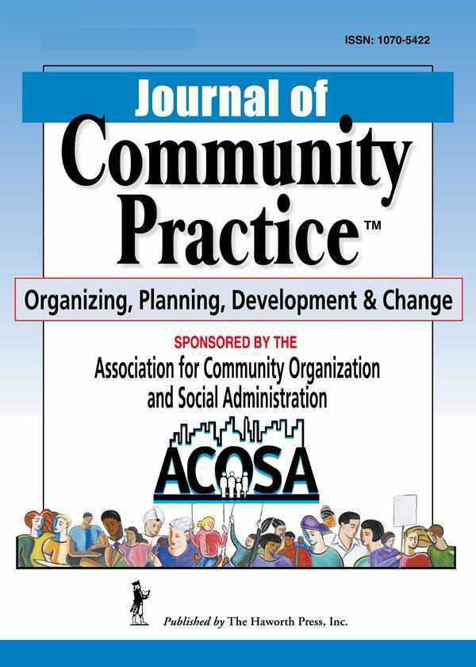


Call for Papers

The Journal of Community Practice announces a call for papers to appear in a special issue of the journal related to the theme " Interdisciplinary Scholarship for Community Practice," guest edited by Lorraine M. Gutierrez, Larry Gant and Katie Richards Schuster at the University of Michigan.

At the turn of the 21st century, we would not have envisioned the challenges and opportunities that exist today in our nation and the world. In 2000, we would not have predicted the degree to which global and domestic terrorism, economic adjustments, natural disasters, migration and immigration, new and emerging technologies, globalization and other phenomena would impact the structure and substance of our lives. The conditions of this past decade have affected us all. Economic trends have taken a significant toll on the lives of those who are most vulnerable. These challenges are not unique to the US and are mirrored around the globe.

But with these challenges, the 21st century also offers opportunities that are possible in an increasingly technological and interconnected world that can create possibilities for multicultural, intergenerational participation, innovative models of community organization, cross-sector collaboration, participatory media, and new forms of knowledge development. What is the role of community practice in this environment?

We are interested in scholarly papers focused on the continuing evolution of community practice for meeting the needs of an increasingly changing world. We are particularly interested in papers that focus on the implications of emerging demographic trends and social conditions, the emergent research methods, and the use of innovative methods, such as the arts or information technology, in community practice. As an interdisciplinary journal grounded in social work, we encourage papers that demonstrate interdisciplinary collaboration and community-based scholarship.

Submission: Manuscripts should be submitted online by April 1, 2013 and labeled FOR SPECIAL ISSUE for consideration by the special issue editors. Submission is via http://mc.manuscriptcentral.com/wcom. Manuscripts may be approximately 25 typed pages double-spaced (including the abstract, references, tables and figures). Please contact Lorraine Gutierrez (lorraing@umich.edu) with any questions about this special issue.

