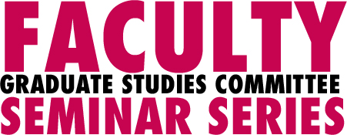
VISUAL THEORIES OF CHANGE: Awakenings from colonisation
Presented by Dr Ingrid Huygens
9 July 2010
1.00pm – 2.15pm
D531, Footscray Park Campus
About the talk
With her activist colleagues In New Zealand, Dr Ingrid Huygens has developed a ‘visual theorising’ method to depict Pakeha change as experienced by participants. She will discuss how her innovative interactive and consensual method challenged conventions of qualitative data gathering. She will also show a number of the visual theories and images of colonisation, cultural journeys, and individual and collective change relevant to New Zealand and Australia.
About the Presenter
Dr Ingrid Huygens, University of Waikato Psychology Dept & WINTEC School of Social Development, has recently completed a PhD in processes of Treaty-focused change in Aotearoa, and works nationally as a Pakeha Treaty educator and consultant. Her background is in social, community and critical psychology. She is co-author with Marewa Glover and Pat Dudgeon of ‘Colonisation and racism’ in Nelson & Prilleltensky (2010).
Who should attend?
This seminar will be of interest to all staff, students and interested community members interested in social change and the use of innovative methodologies in change oriented social research.
This presentation is sponsored by the Associate Dean (Research and Research Training), Faculty of Arts, Education and Human Development, Victoria University.

A Light lunch will be provided. RSVP 8 July 2010 for catering purposes.
For further information please contact Grace Schirripa at grace.schirripa@vu.edu.au.

