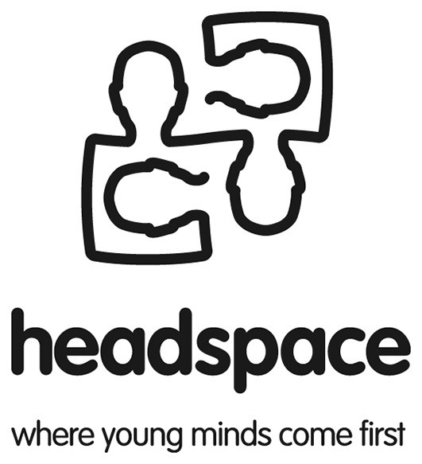

Position Description

Title: | Research Assistant – headspace: The National Youth Mental Health Foundation
Location: | APS National Office – 257 Collins Street, Melbourne
Position reports to: | Darryl Wade headspace Education and Training Coordinator
Position type: | Casual part-time (2-3 days) contract to Dec 2007, with potential for extension of contract

1. Position context
The APS is seeking a Research Assistant to undertake activities associated with the Service Provider Education and Training Program of headspace: The National Youth Mental Health Foundation.

A consortium, which consists of the ORYGEN Research Centre (University of Melbourne) as lead agency, the Australian General Practice Network (AGPN), the Australian Psychological Society Limited and the Brain and Mind Research Institute (University of Sydney), is establishing headspace, an initiative funded by the Australian Government. headspace is supported by $54 million in Australian government funding for the period 2006-2009.

The mission of headspace is to reduce the burden of disease in young people aged 12-25 years caused by mental health and related substance use disorders through early identification and effective, evidence-based intervention delivered by primary care and specialist providers working together within a unified, accessible and integrated service framework.

headspace will achieve its aims by:
- Encouraging early help-seeking by young people with mental health and related substance use disorders, and their supporters, through the development and implementation of local and national community awareness activities;
- Assisting a range of service providers working with young people to build their skills in engagement, assessment and the provision of evidence-based treatments, through the development and dissemination of evidence-based education and training resources and initiatives;
- Supporting the development of more accessible, integrated and effective approaches to service delivery for young people with mental health and related substance use disorders in local communities across Australia, through the administration of a national service enhancement and coordination grants program; and
- Promoting the dissemination and uptake of evidence-based practice in youth mental health, through the creation of a Centre of Excellence.

headspace activities will be organised into four program areas aligned to the organisation’s key objectives. The four Program Areas are:
- The Service Enhancement and Coordination (Grants) Program
- The Centre of Excellence Program
- The Service Provider Education and Training Program
- The Community Awareness Program.

headspace has established a Foundation Executive Committee (FEC), which includes a senior representative from each of the four consortium member organisations to oversee the implementation and development of headspace.

The Australian Government has nominated an Advisory Board, which includes prominent individuals and key stakeholders from the community, business and government sectors to provide advice and support to the FEC to assist it to fulfil the objectives of headspace.

A Senior Executive Team, consisting of the CEO, Program Director and Business Manager will have the responsibility of coordinating and contributing to the development and monitoring of the four program areas. A consumer and a carer advocate will be employed part-time to work with the Senior Operations Executive to assist with the development and implementation of a consumer and carer participation strategy.

APS role in headspace
The APS has received funds to co-lead, in partnership with the Australian General Practice Network (AGPN), the development of the Service Provider Education and Training Program. The Program will provide education and training opportunities to clinical and non-clinical service providers in primary care and specialist settings, as well as participants in headspace Communities of Youth Services (CYSs). Education and training will involve skills development in engaging, assessing and providing evidence-based treatments to young people with mental health and substance use disorders. It is expected that the Program will influence the nature of existing professional training agendas, particularly to promote innovative cross-disciplinary training approaches at the postgraduate and continuing professional development levels.

An APS headspace project team, led by the Education and Training Program Coordinator, has been established to undertake the activities of the Service Provider Education and Training Program. During the first twelve months, the APS headspace project team will be responsible for:
- Identifying the training needs of all identified youth mental health service provider groups via focus groups and surveys
- Conducting a literature review of models of effective training
- Conducting an audit of existing youth mental health training and education programs and resources
- Producing a training and resource guide and framework for training manual for CYSs
- Conducting train-the-trainer workshops for trainers from each CYS
- Developing an evaluation strategy for the Education and Training Program

2. Specific duties and responsibilities
Under the direction of the headspace Education and Training Coordinator and in collaboration with other headspace project staff, the Research Assistant will undertake and/or contribute to the following activities:
- Design and develop survey database
- Undertake entry and analyses of quantitative survey data
- Undertake analyses of qualitative focus group data
- Write summary reports
- Assist with audit of training programs and resources including development of resource guide
- Assist with adaptation and/or development of additional modular-based training programs and resources to address gaps in available packages
- Undertake clerical and administrative duties

3. Knowledge, experience and key attributes
Essential
- Currently undertaking postgraduate qualifications in psychology
- Well developed qualitative and quantitative research skills including use of SPSS statistical package
- Well developed written communication skills
- Well developed interpersonal skills and the ability to work in a team
- Ability to plan and manage time effectively, meet deadlines and work independently
- Computer literacy

Desirable
- Knowledge of and experience in youth mental health

Closing date for applications: Thursday 3rd May, 2007

Written applications must address the essential criteria for the position and include the names and contact details of three referees.

Please forward applications to Darryl Wade, headspace Education and Training Coordinator.

By email: d.wade@psychology.org.au

By mail: Darryl Wade
headspace Education and Training Coordinator.
Australian Psychological Society
PO Box 38
Flinders Lane PO
Melbourne
VIC 8009

For further information, please contact Darryl Wade on 03 86623312 or 0421607884.

